NAME____________________________LAB MEETING DAY/TIME______________

Lab 9: The Cordilleran Orogeny

In this lab you will continue to examine geologic maps and explore the development of the North American continent in the Mesozoic. You will be completing Exercise 17 in your lab manual.

# **Pre-Lab Questions**

**To prepare you for this lab, here are a few review questions to get you thinking about the Cordilleran Orogeny. Use your textbook or the lab pre-reading to answer these questions. If you use online sources, cite them and use your own words.**

**What are the names and geologic timing of the three phases of the Cordilleran orogeny? On the map here, shade in the general regions for these three phases and label them.**

|  |  |
| --- | --- |
| **Phase Name** | **Phase Timing** |
|  |  |
|  |  |
|  |  |
|  |  |

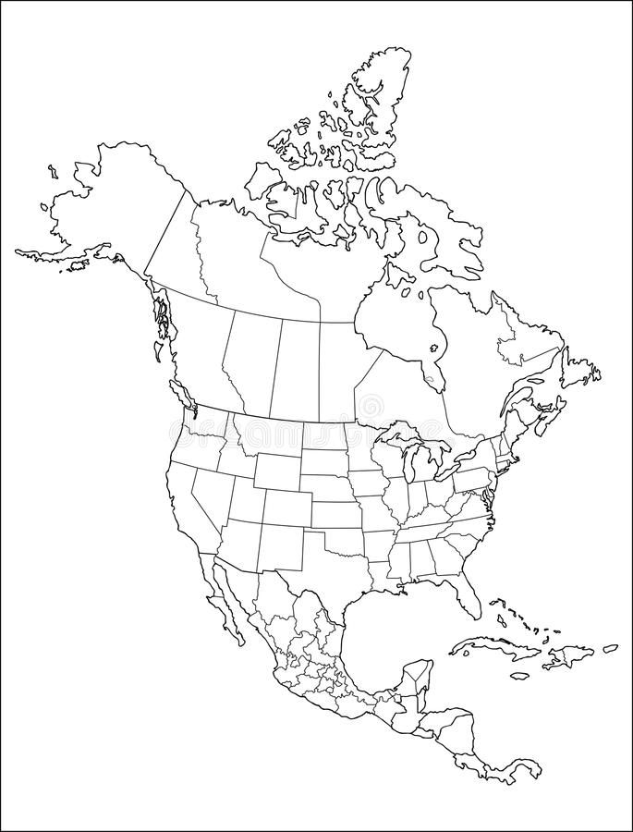

# **Exercise 17, Part A**

**Mark / label the approximate location of Yosemite National Park on the map above; this is the area we are reviewing in this part of the exercise.**

**Question 1. Use the map and its legend to answer this question. Circle one**

*intrusive igneous extrusive igneous sedimentary metamorphic*

**Question 2. You may have to do some outside research to answer this question. Answer in your own words and cite your source.**

**Question 3. Use the map and its legend to answer this question.**

**Question 4.**

**Question 5. You may need to refer to your textbook for this one…what tectonic processes forms the rock types seen here?**

**Question 6. SKIP this question.**

*These are the Paleozoic host rocks into which the magmas intruded.*

**Question 7. Use your answer to question 3, and the pre-lab questions on the previous page to answer this question.**

# **Exercise 17, Part B**

**Read the introduction to this activity. Mark / label the approximate location of Chouteau, Montana on the map on the first page of this lab; this is the area we are reviewing in this part of the exercise.**

**Question 1. “Fabric” means the orientation and shape of the mountain ranges.**

**Question 2. Summarize the rock types / ages for this question, using the map legend.**

**Question 3.**

**Question 4.**

**Question 5. Review page 205 of the lab manual to understand the map symbols. Focus on drawing the orientation of the thrust faults.**

**Question 6.**

**Question 7. Note that on the map, north is up / at the top of the map.**

**Question 8. Think about the ages of the rocks present. Also, note that the Quaternary sediments cover the faults in some places.**

**Question 9. Use your answer to question 8, and the pre-lab questions on the previous page to answer this question.**

# **Exercise 17, Part C**

**Read the introduction to this activity. Mark / label the approximate location of the Bighorn Mountains, Wyoming on the map on the first page of this lab; this is the area we are reviewing in this part of the exercise.**

**Question 1. Review the cross section below, instead of drawing your own. Use this to answer the question.**

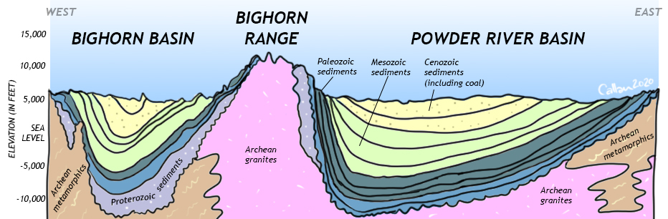

*(Image source:* [*https://opengeology.org/historicalgeology/case-studies/western-mesozoic-orogenies/*](https://opengeology.org/historicalgeology/case-studies/western-mesozoic-orogenies/)*)*

**Question 2. Use the cross section above, and the map in the exercise to think about this question: These are either domes or basins. Which are they, and how do you know?**

**Question 3. Use the cross section below, from the area just south of Worland on the map to help you answer this question. The Cenozoic rocks in this region are not folded – what does this tell you about the timing of deformation?** Write your answer to the right of the cross section.

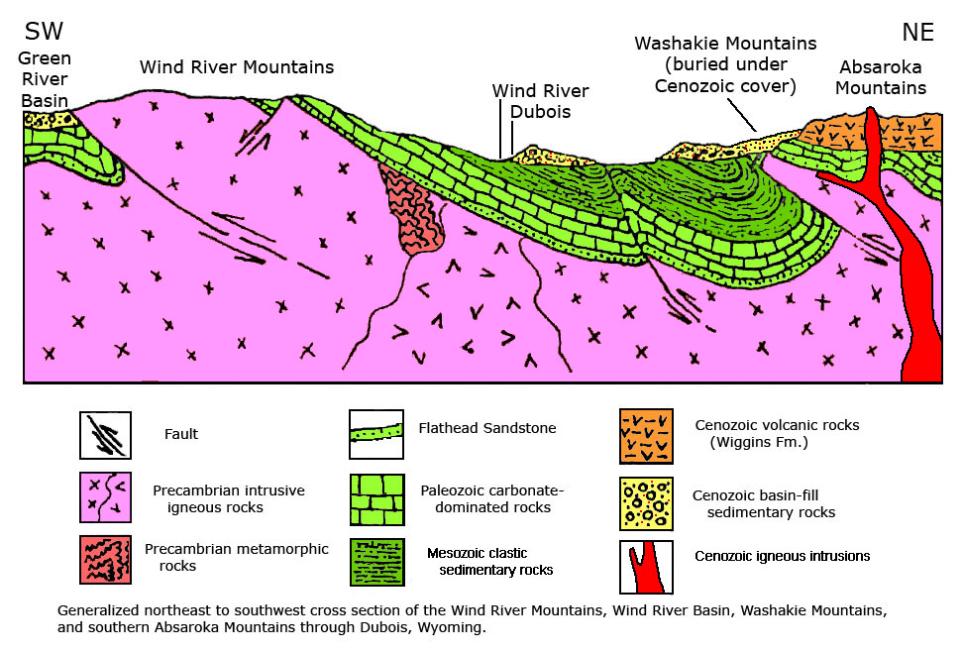

**Question 4. Refer back to figure 17.5 on page 254 of the lab manual to answer the first question. Then refer back to pages 220 – 221 to answer the second question.**

# **Exercise 17, Part D**

**Read the introduction to this activity. Mark / label the approximate location of the Black Hills, South Dakota on the map on the first page of this lab; this is the area we are reviewing in this part of the exercise.**

**Question 1. Use the map on page 270, and the legend on pages 268 – 269 to answer this question.**

**Question 2. Refer to your textbook Appendix D on sedimentary structures, and think about the ages of the rocks in the circular structure to answer this question.**

**Question 3. Use the map and legend to answer this question; fill in the table below.**

|  |  |
| --- | --- |
| *Area* | *Rock Type(s)* |
| *Core of Black Hills* |  |
| *Flanks (edges) of Black Hills* |  |
| *Plains to east* |  |

**Question 4. Think about your answer to the question above to answer this one. The core and flanks represent the uplift, and the plains were deposited after the uplift.**

**Question 5 & 6. SKIP these questions.**

# **Exercise 17, Part E – SKIP THIS PART**

# **Exercise 17, Part F**

**Read the introduction to this activity. Using Figure 17.13 shade / mark the general location of these rocks on the map of the first page of this lab.**

**Question 1. A lithofacies map shows the different rock types of an area. To construct this map, choose a color for each of the rocks discussed in the introduction to this section. Color the dots for those, and then shade in the regions for each rock type. Include a legend below.**

**Question 2:**

**Question 3: Think about your answer to question 2 to answer the first question, and the map you’ve been filling in on the first page of the exercise for the second question. Also suggest the orogeny that provided the sediments here.**

**Question 4. Skip this question.**

*The answer is no, because the Colorado Rockies formed in the Cenozoic. But that is not evident in this map.*

**Question 5. Think about how sediments accumulate, and what thickness you would expect nearest their source and furthest from their source.**

# **Lab 9 Reflection**

**What concepts were most difficult in today’s lab activities?**

**What concepts were easiest to grasp?**

**What questions did today’s activities make you think of? What do you want to learn more about?**